# Problem 4 – Ski Vacation

In this task you have to create simple ski vacation booking system. You should save every booking in MySQL database. Create a button to show all the reservation currently in the database. Add functionality to delete the reservations. Create two of the table fields editable so you can update the reservations in the database. Data should be shown in HTML table below the booking form. The design of the database is up to you. The booking form should consist of the following sections:

### Note

Submit your HTML, PHP and SQL data in a single zip file. Make a full SQL extract – structure and data. Quality of the PHP code will be evaluated as the SQL design not just the functionality of the system. HTML quality will not be taken into account but it is good to be at least readable.

### Personal Information

In this section you should define the following fields. All fields are mandatory.

* First Name – text field.
* Last Name – text field.
* Phone Number – text field, only numbers are considered valid input.
* Email Address – email field, should be tested if it is properly formatted email. You can apply the regex that is given to you in the lectures.
* Confirm Email Address – email field matching the upper one exactly.

### Accommodation Details

In this section you should define the following fields. **Rooms** field is optional if the type of accommodation cannot be divided into rooms.

* Type of Accommodation – a dropdown list, minimum two should be added. For example – hotel, hostel, bungalow, etc.
* Number of Children - number field, only numbers are considered valid input.
* Number of Adults – number field, only numbers are considered valid input.
* Rooms – number field, only numbers are considered valid input.

### Vacation Details

In this section you should define the following fields. **Check-In Date** and **Check-Out Date** are mandatory.

* Check-In Date – date filed.
* Check-Out Date – date field.
* Lift Pass – checkbox field.
* Ski Instructor – checkbox field.

### Constraints

* Text fields should support Unicode characters, except other noted.
* All error messages should come bellow the form. The format and message of the errors is up to you, but they should be meaningful.
* A person could make more than one reservation.
* The form should remember its last state in case of error. The user should not be required to reenter all the information again, just correct the problem.
* Format of the date fields is up to you, needs to be understandable.
* Output table should be sorted in ascending order: reservations that have earlier start date on top, if there are several reservations with the same start date, you should sort them by earlier end date.
* Styling of the HTML is not required, only functionality is important.

### Example

**Input Form**

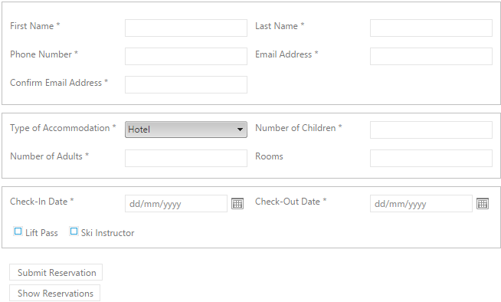

**Reservations Table**

